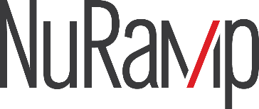

Agreements Module

User Guide

Contents
Introduction 1
Purpose 1
Audience 1
When Do You Need to Complete an Agreement Form? 1
Review Timeline 1
System Overview 2
Workflow 2
Roles and Responsibilities 2
NuRamp Login/Agreements Menu 3
Creating an Agreement Request 5
Complete an Agreement Form 6
Submission and Review Process 9
Viewing Existing Forms 11
Agreements and Forms Index Pages 11
Customizing Table Appearance 12
Form Summary 13
Key Information 13
Workflow Progress 13
Personnel 14
Agreement Summary 14
Compliance Questions 14
Related Projects 14
Comments 15
Messages 15
Tags 15
Status Changes 16
Viewing Files 16
Common Form Statuses 18
Additional Form Types 19
Overview 19
Change Form 19
Reportable New Information Form (RNIF) 19
Continuing Review 19
Final Report 19
Adding a Form to the Agreement 19
Support 21

Introduction

Purpose
This guide explains how to create, submit, review, approve, and track unfunded agreements within the NuRamp electronic research administration (eRA) system.

Audience
- Principal Investigators (PIs)
- Departmental Research Administrators
- Office of Research & Innovation staff

When Do You Need to Complete an Agreement Form?
An unfunded agreement should be initiated when an institution is committing to perform activities without receiving direct funding, but where the work still carries legal, compliance, or institutional risk. This includes sharing or receiving data, materials, or specialized tools (e.g., datasets, samples, software, equipment access, or proprietary methods being exchanged for research or reporting purposes).
Currently, the NuRamp Agreements module supports three unfunded agreement types:
- Data Transfer and Use Agreement (DTUA)
- Material Transfer Agreement (MTA)
- General International Memorandum of Understanding (GIMOU)
- Other Agreement (excluding CDA/NDA)
Examples of Other Agreements include, but are not limited to, equipment loans, site/location access, unfunded industry collaborations/MOUs, and domestic student placement.
Additional agreement types will be added in the future.

Review Timeline
The review and execution timeline for an unfunded agreement depends on the complexity of the request and the responsiveness of the external party. OSP and compliance review intake forms in the order received; however, completing an agreement may take approximately 6–8 weeks from receipt, or longer for complex cases. Early initiation is strongly encouraged to avoid delays.

System Overview

Workflow
Responsibility for initiating a NuRamp Agreements form rests on the PI and their support personnel. Anyone can create a form in the Agreements module and enter data into the form. However, only the person listed as the PI on the form can submit it for review and execution. The flowchart below outlines the high-level process.

A form may be returned to the investigator for additional information/clarifications at the Pre-Review and/or Compliance Review steps in the workflow.

Roles and Responsibilities
Role | Responsibilities
Requestor* | Creates Agreements form and completes requested information
PI | Completes/reviews requested information and submits the form
OSP Administrator | Coordinates institutional review and agreement processing
Compliance Officer | Reviews regulatory issues
* The requestor and PI may be the same person.

NuRamp Login/Agreements Menu
Log into NuRamp using your campus credentials.
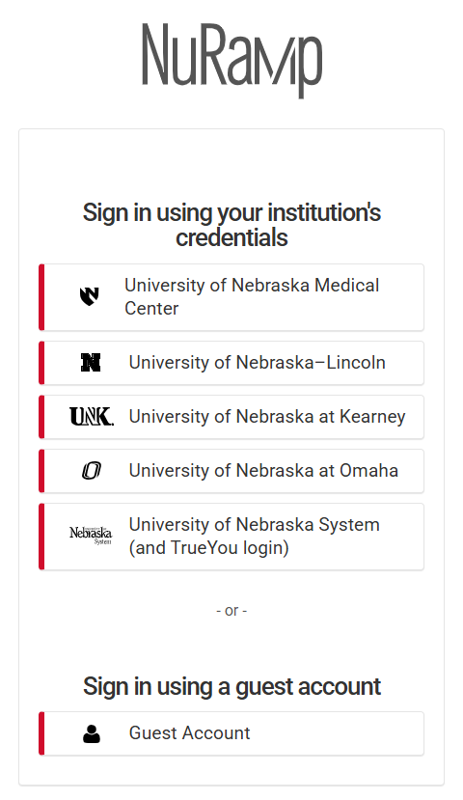
Click on the three bars in the upper left corner or the word Modules to access the menu. Click on Agreements at the bottom of the menu.
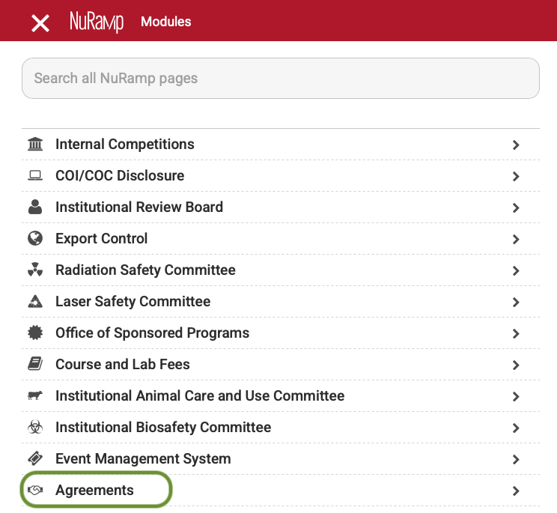
Click on Agreements or Forms to view the list of forms to which you have access.
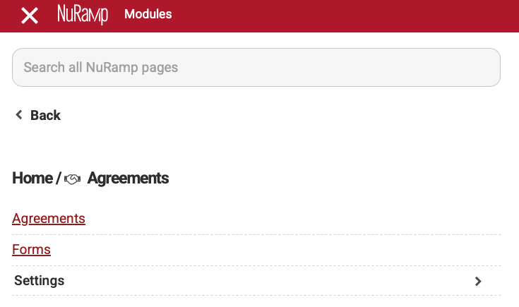

Creating an Agreement Request
There are two ways to create a new Agreement form. The simplest is to click the plus sign in the upper right corner of any NuRamp screen and choose “Add New Agreement.”
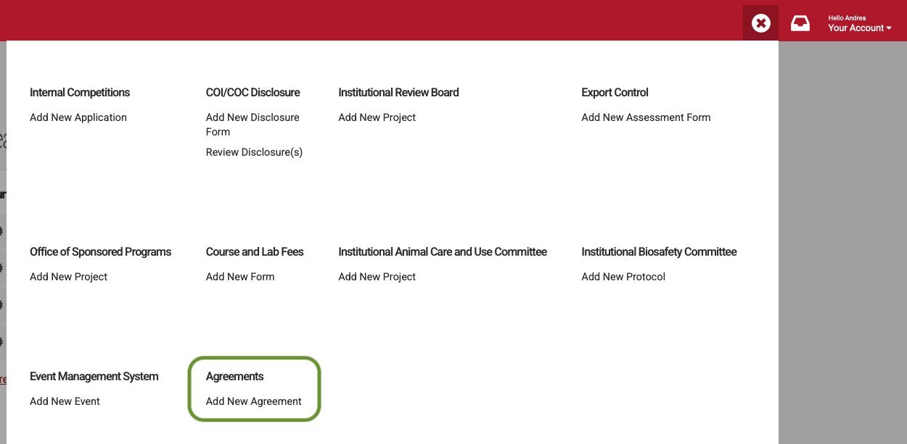
Alternatively, from the Agreements page (accessed via the Agreements module menu), click the “Add a New Agreement” button near the top of the page.
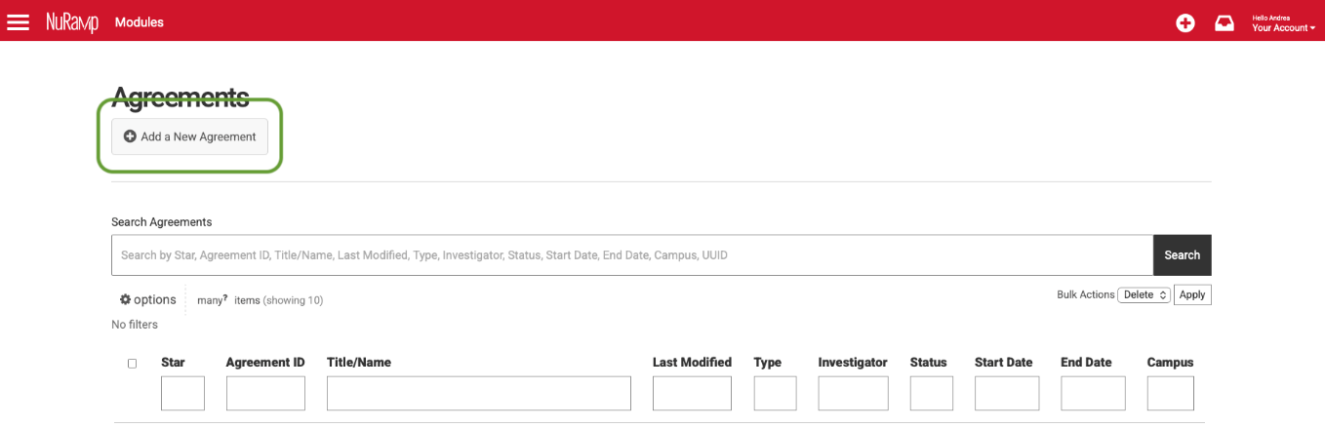

Regardless of which method you use, you will be directed to page to choose which type of Agreement form you wish to create.
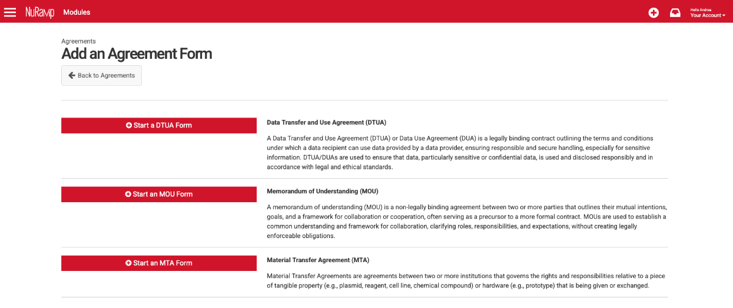

Complete an Agreement Form
When you start a new form, you are immediately taken into the Form Preparation workflow to enter the required information.
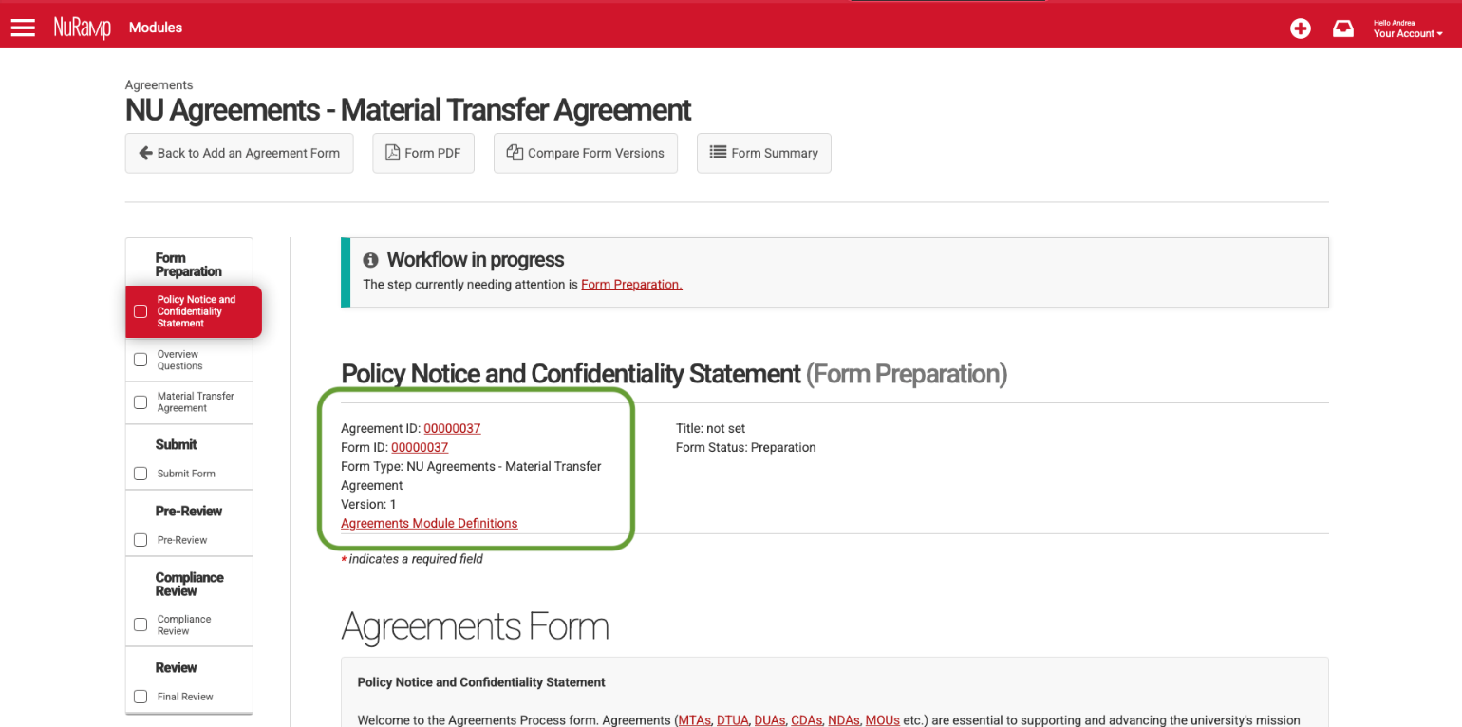

Some fields have a minimum character count or other validations. If these requirements are not met, you will receive an error when saving the page.
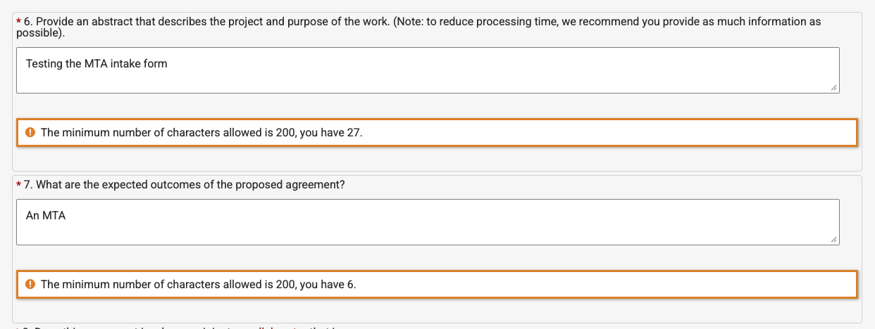
Some questions allow you to link the Agreement Form to other NuRamp modules (e.g., Sponsored Programs, Instituttional Review Board).
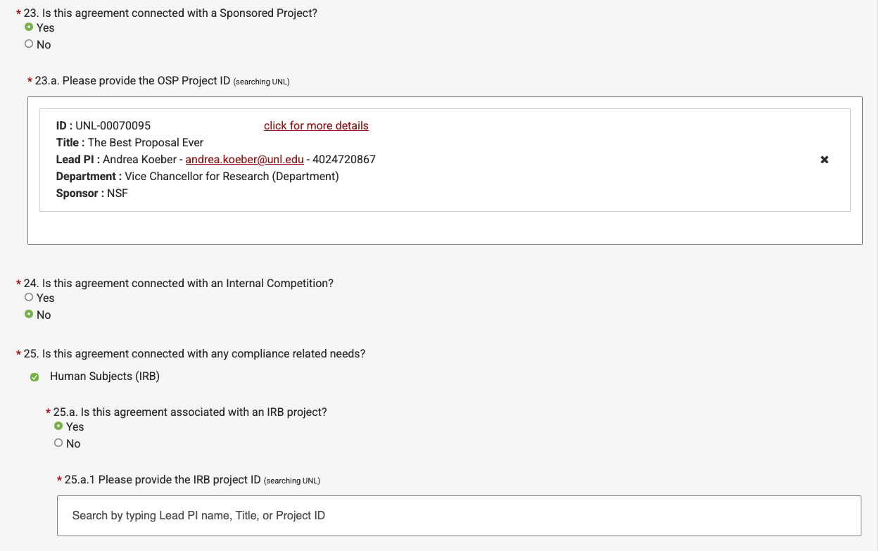

Some questions may not be displayed depending on your answers to previous questions.
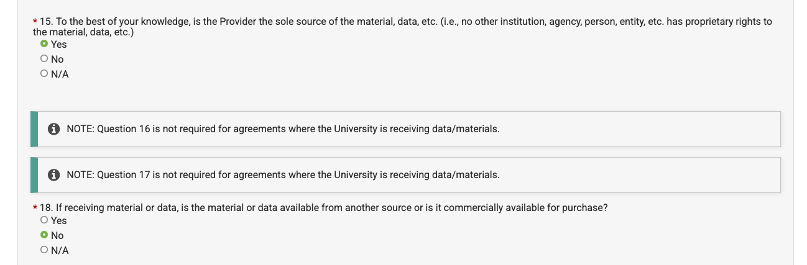
Throughout the form, there are red hyperlinks that take you to a definitions page.
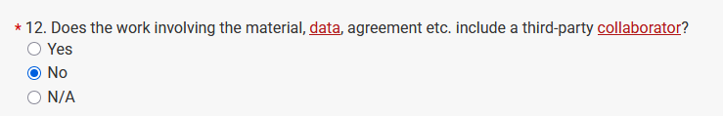
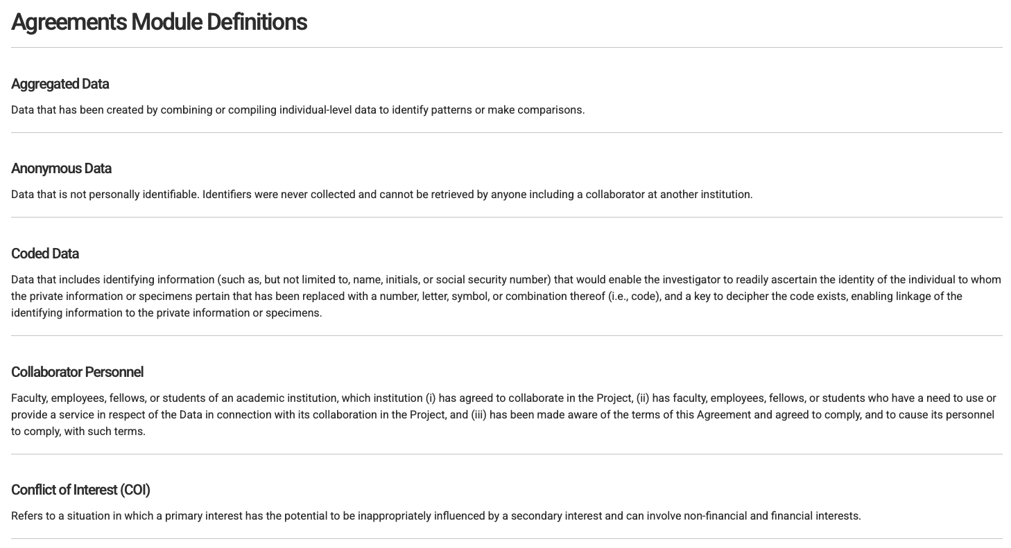

Some forms have a second page of questions specific to the agreement type (e.g., MTA or DTUA).
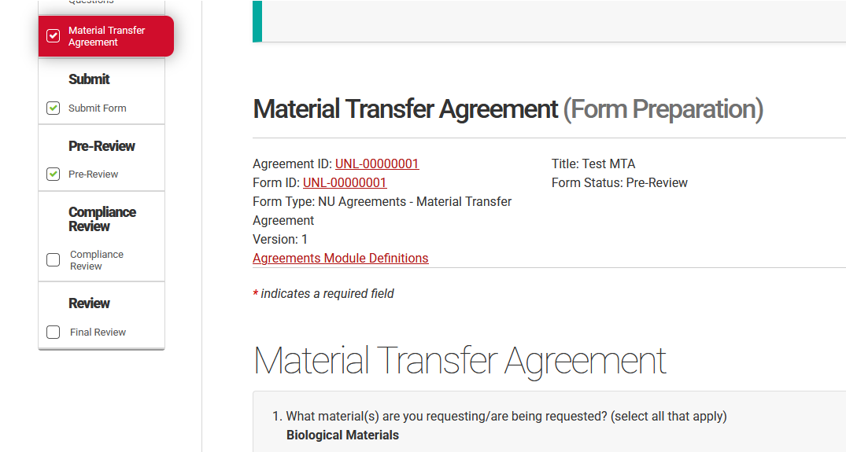
You do not need to complete the entire form at once; you can save and come back later to finish.
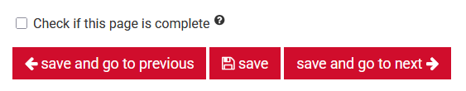
When you have completed all information requested on the page, check the box at the bottom of the page, and click any of the save buttons.

Submission and Review Process
Once all information has been entered into the form, the boxes at the bottom of the pages checked, and the form saved, each step in the Form Preparation workflow will show a green checkmark and the form is ready to be submitted to OSP to begin review.
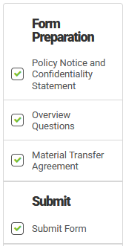
Note that while anyone can start a form and enter data, the form can only be submitted by the PI.
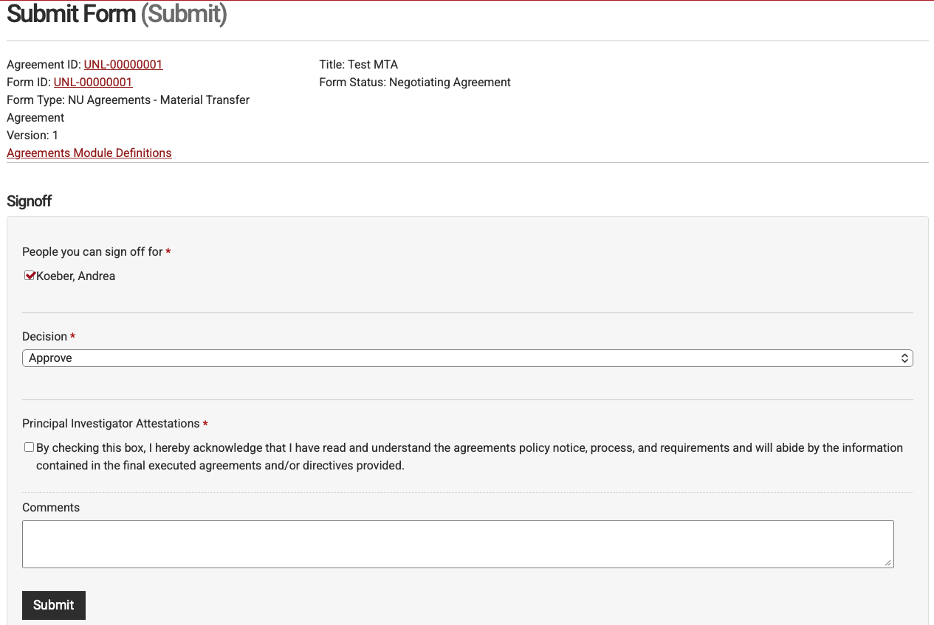
Once the form has been submitted, the Sponsored Programs team will review it for completeness. If they have everything needed to process the agreement, they will move it forward to Compliance Review (if relevant). If there are no compliance elements, the form will move on to the Final Review workflow for execution.
If a Compliance Review is completed and one of the compliance offices requests revisions on the form, a member of the Sponsored Programs team will reach out to the PI via email to request these revisions. Once the revisions are submitted and the compliance office(s) have signed off on the form, it will move forward to Final Review for execution.

Viewing Existing Forms

Agreements and Forms Index Pages
Existing Agreement Forms can be accessed via the Agreements and Forms pages in the NuRamp menu. An Agreement record contains at least one Form, though sometimes there will be more than one form. (If you are familiar with the NuRamp Sponsored Programs module, these are the equivalent of OSP Projects and Forms.)
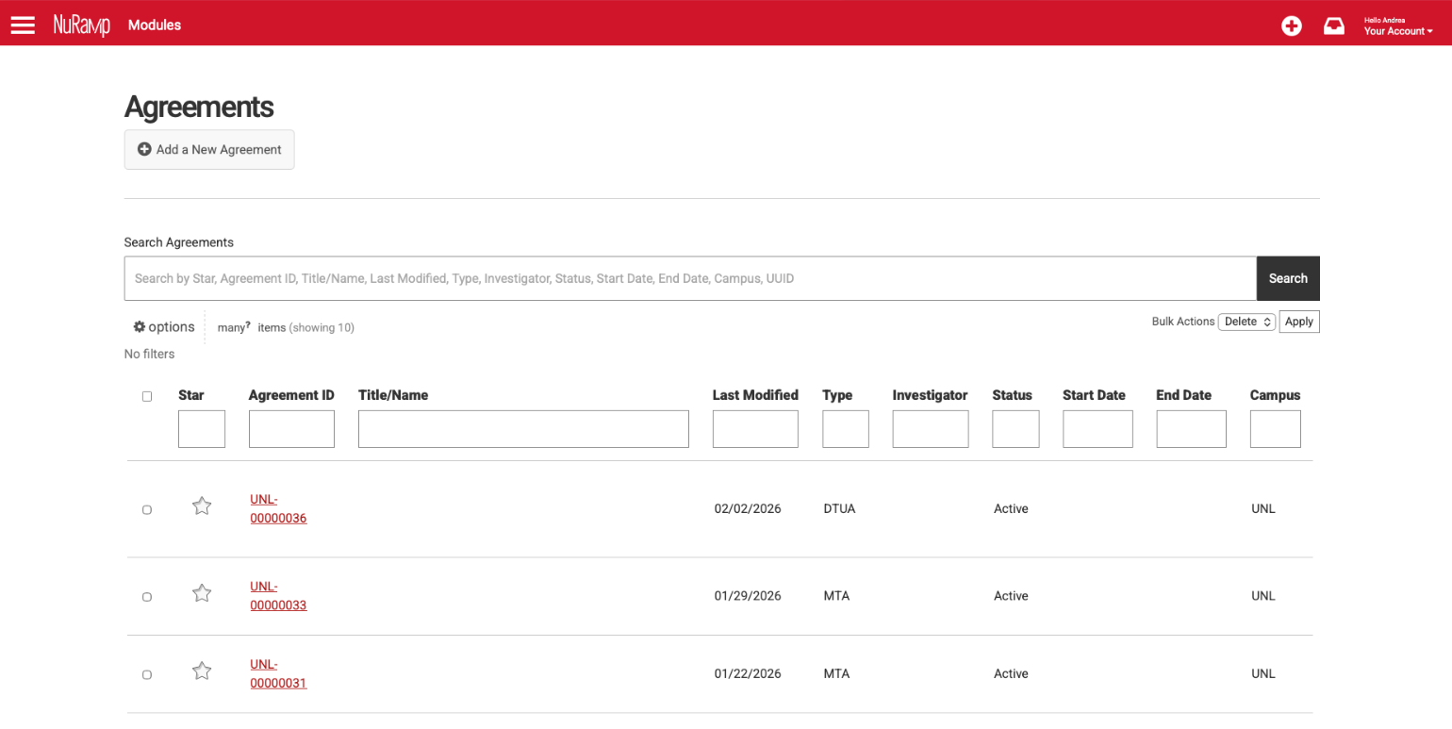
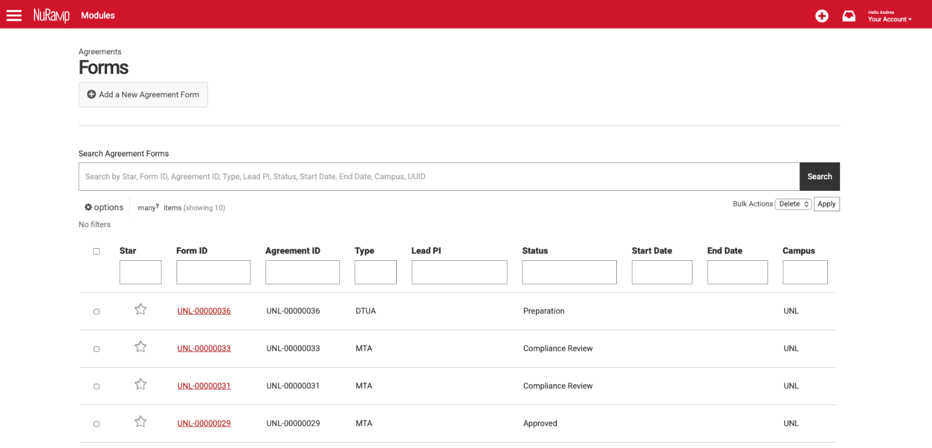

Customizing Table Appearance
You can personalize the look of the filters and the columns displayed on the Agreements and Forms pages, as well as how the columns are sorted by clicking on Options.
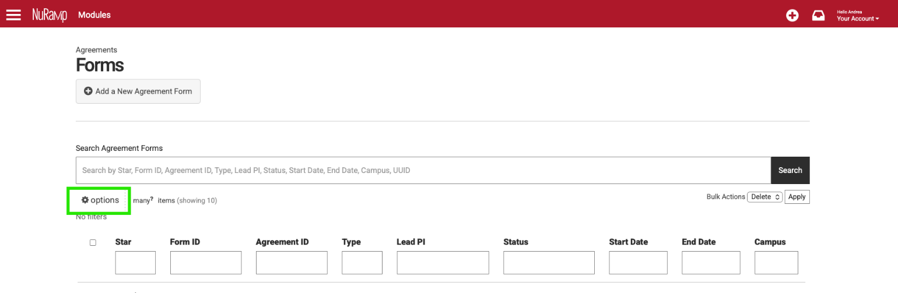
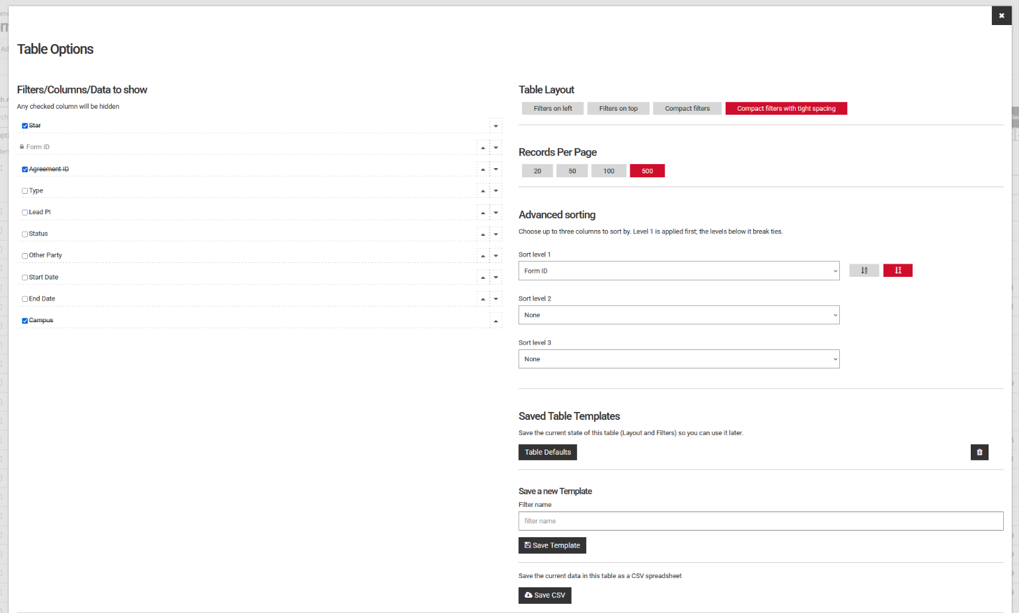

If you would like these preferences to be saved, click the Save my preferences button in the dialog that appears at the top of the Options screen.
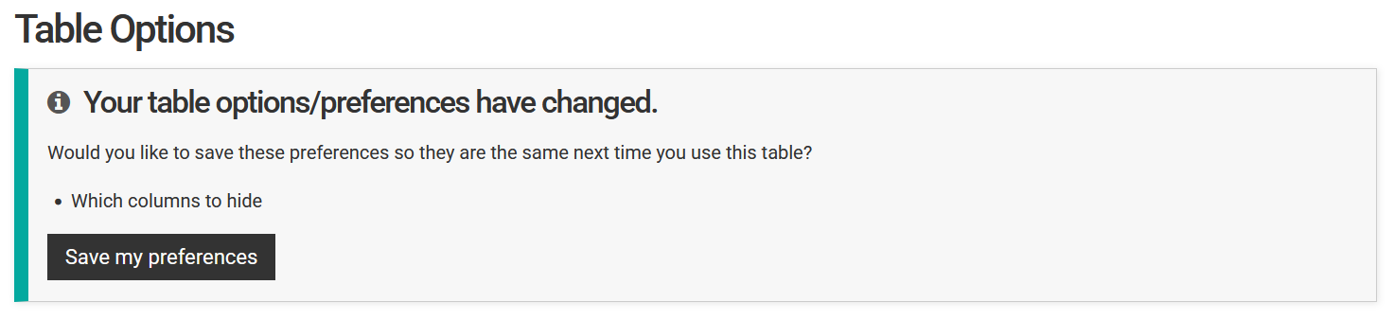

Form Summary
The Form Summary page displays the data entered on the form in the Form Preparation workflow. It is divided into ten sections described below.

Key Information
The Key Information section provides critical information, such as the investigator name, who the agreement is with, etc. It also contains a link to the files that have been uploaded to the form.
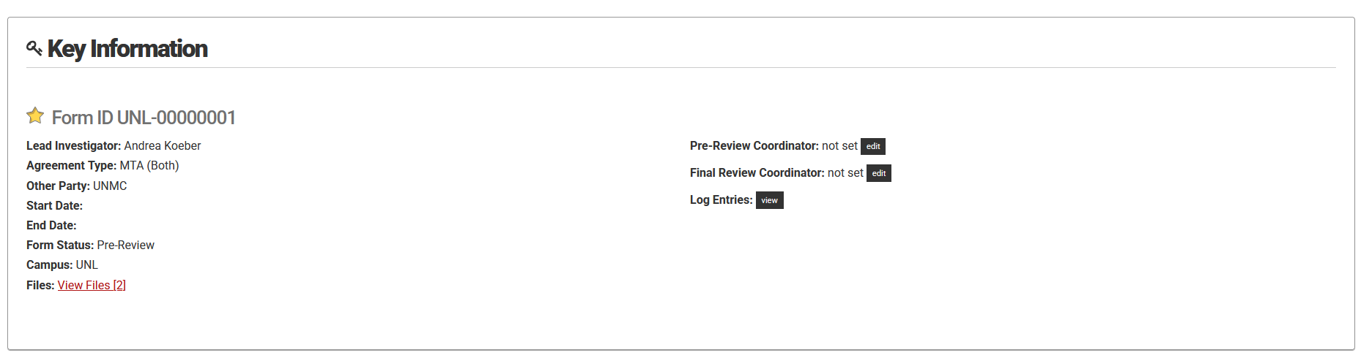

Workflow Progress
The Workflow Progress section displays the status of each step in the form’s progress. Items marked in green have been completed, while gray items are in progress or have not yet been started.
Each of these buttons is a link. If you have started preparing the form and need to enter more data, click on the Form Preparation button to be taken to the data entry screens. (Note that once a form has been submitted, these screens will be read only for most users.)
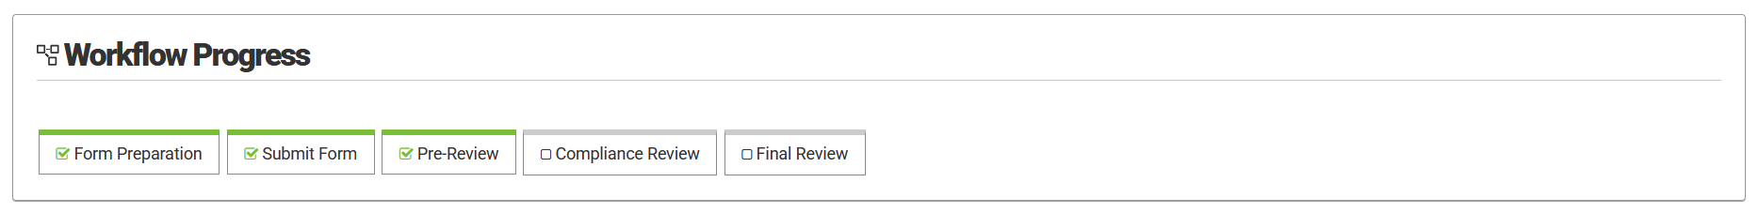

Personnel
The Personnel section lists the lead investigator’s name, department, college, COI/COC status, COI/COC training status, and RCR training status.
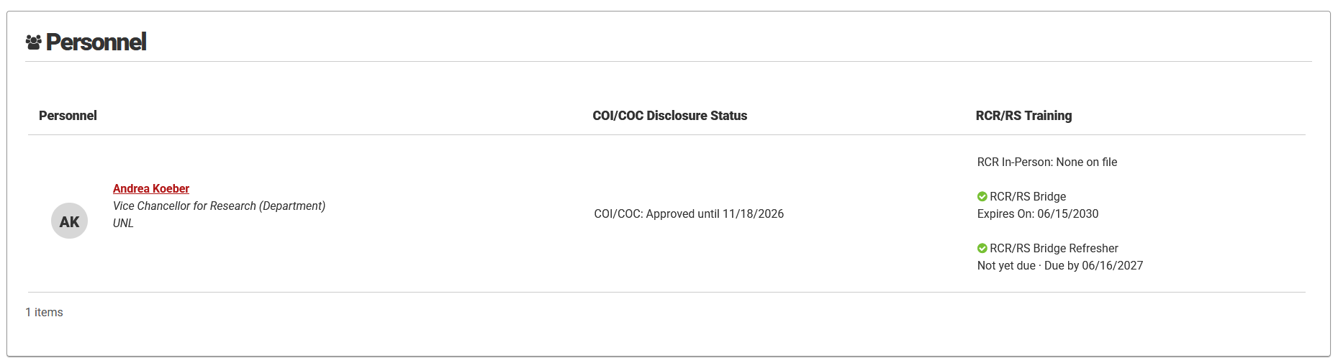

Agreement Summary
The Agreement Summary displays the text that was entered in the abstract field in Form Preparation.
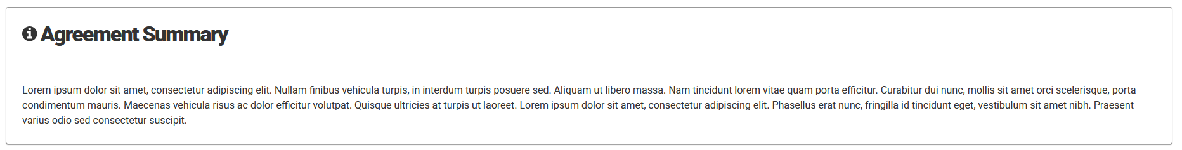

Compliance Questions
This section displays the answers to the compliance-related questions completed in Form Preparation.
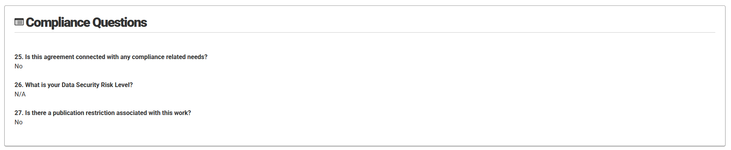

Related Projects
This section displays projects identified as being related to the current Agreement in Form Preparation.
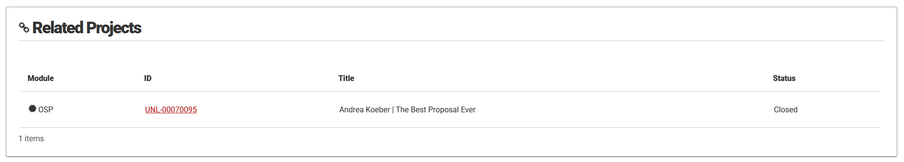

Comments
This section displays any comments made on the form and provides a place for users to make comments. Depending on your role and where the form is at in the process, you may be able to edit your comment. For most users, once the form has been submitted, comments cannot be edited. If you need a comment edited, reach out to the support email at the end of this document.
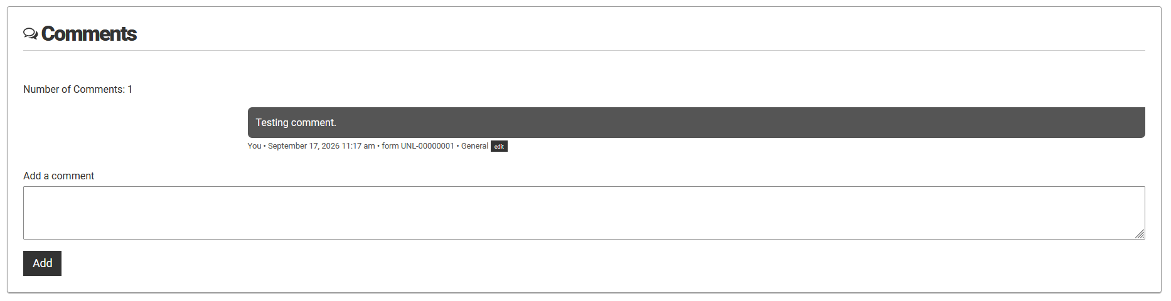

Messages
This section allows the user to see the messages that have been sent through NuRamp, including automated emails triggered by certain actions on the form (e.g., when the form is submitted for review). (Note that most users can view messages but not send them directly and will not see the “Send Messages” button.)
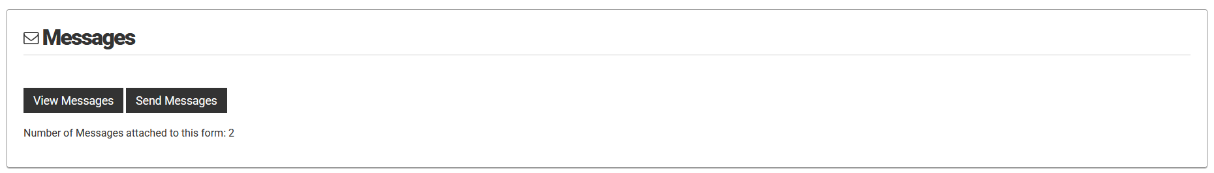

Tags
Tags allow Sponsored Programs (and Global Affairs) to add keywords to forms. This is not currently being used broadly.
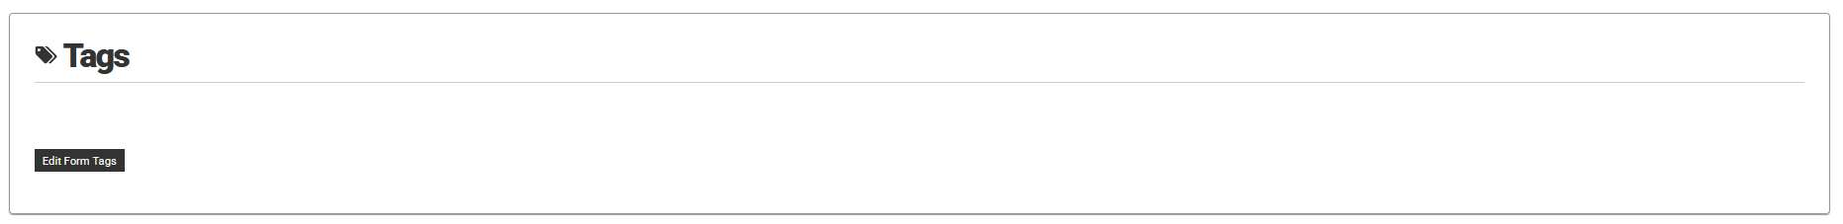

Status Changes
This section of the form displays the various status changes, who triggered them, and when.
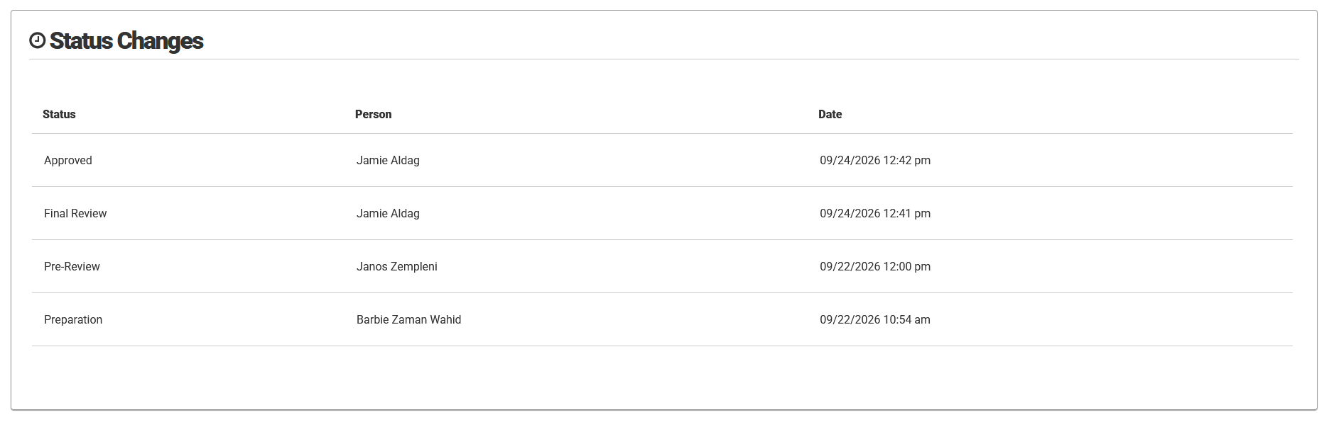

Viewing Files
The files attached to a form, including the final executed agreement, can be accessed via the “View Files” link on the Form Summary page.
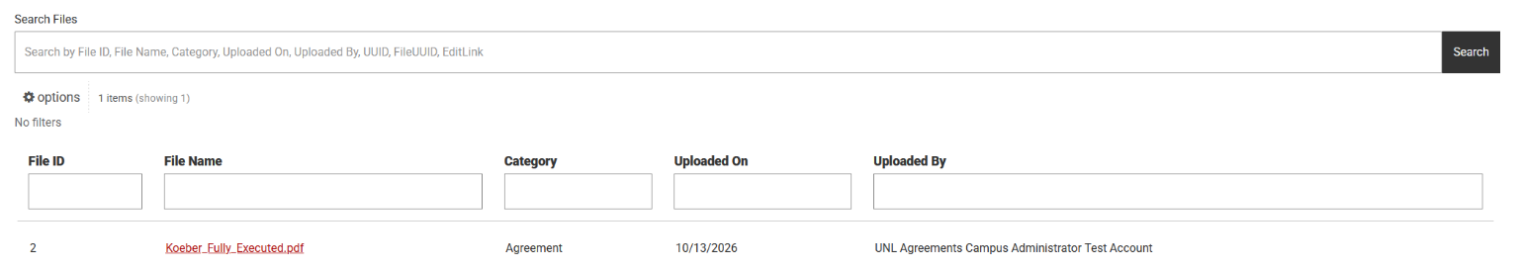

You can personalize the look of the filters and the columns displayed on the Files page, as well as how the columns are sorted by clicking on Options.
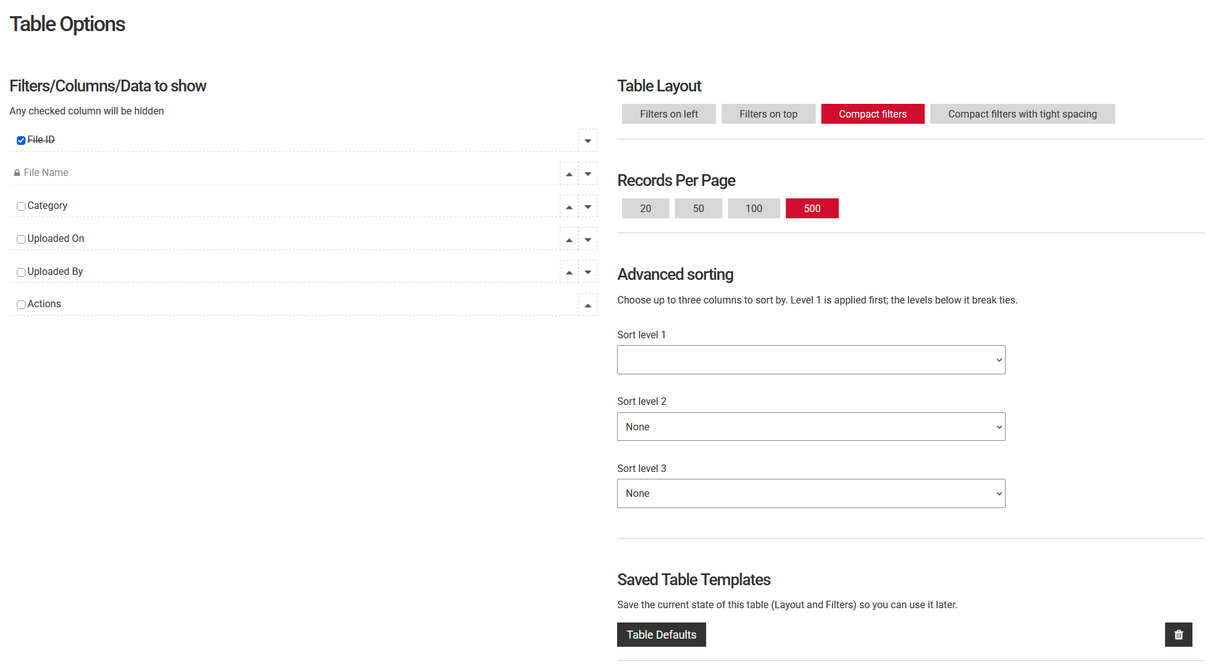
If you would like these preferences to be saved, click the Save my preferences button in the dialog that appears at the top of the Options screen.

Common Form Statuses
A form’s status indicates where it is in the process. Some of the most common status are defined below.
Status | Description
Preparation | Being prepared
Pre-Review | Awaiting initial review
Compliance Review | Under compliance review
Revisions Requested | Revisions have been requested of PI
Final Review | Awaiting execution
Negotiating Agreement | Being executed
Approved | Fully processed and executed
Disapproved | Declined to be processed
Closed | End date has passed

Additional Form Types

Overview
In addition to the main Agreement form, the module also contains several other forms as described below. These forms follow the same review and approval process outlined above for the standard Agreement form.

Change Form
The Change Form is used when you need to make a change to the Agreement. You will be required to provide a description and justification of the proposed changes. The existing Agreement information is populated in the change form and can be edited as needed.

Reportable New Information Form (RNIF)
The Reportable New Information Form is used to report important information about your agreement that needs to be tracked. This includes issues such as failure to comply with terms, audits or enforcement actions, security breaches, or other incidents that require documentation and follow-up. This type of form should be submitted at the time the reportable event occurs.

Continuing Review
The Continuing Review form is used to provide updates on ongoing agreements. It allows you to report on the progress of your project, any changes that have occurred, and any issues that need to be addressed. A continuing review form is required annually until the Agreement is closed.

Final Report
The Final Report form is used to provide a comprehensive summary of a completed agreement. It allows you to document the outcomes of your project, any significant findings, and the overall success of the agreement. A single final report is submitted at the end of the Agreement.

Adding a Form to the Agreement
To add one of the forms described above, click the “Add a new form” button at the top of the form summary page.
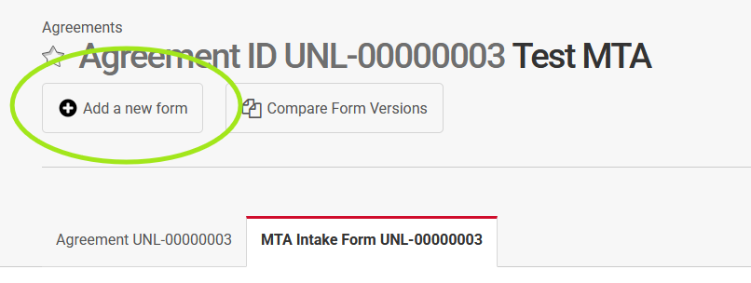
You will be presented with a list of form types that can be added. Once you click the button for the appropriate form type, you will be taken into the Form Preparation workflow to enter/update the required information and submit the form, as outlined earlier in this guide.
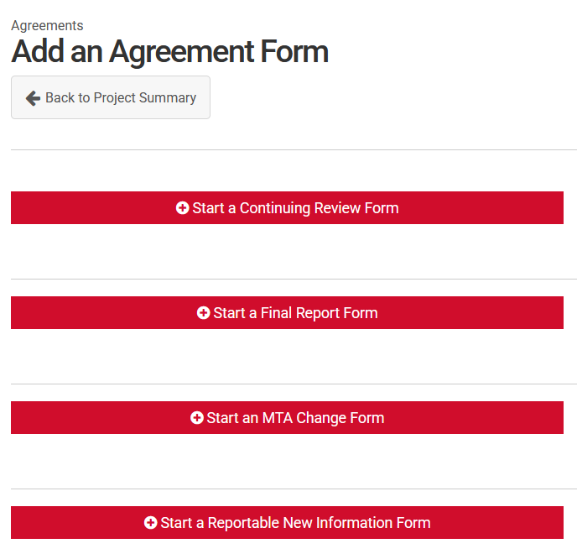
In some instances, one or more form types will be grayed out and cannot be selected. In this case, the reason why a new form cannot be added will be displayed.
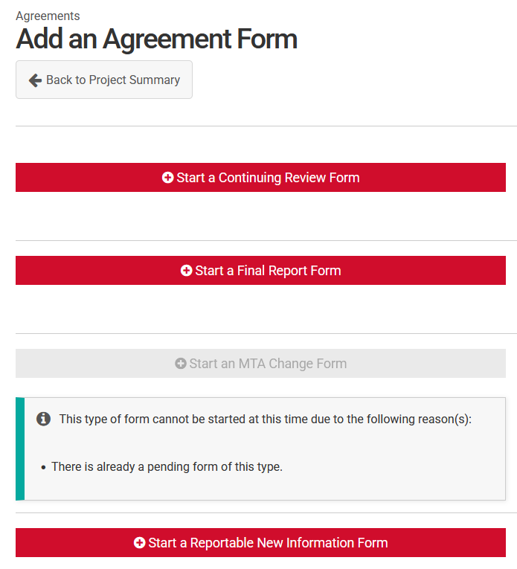
Once the new form has been completed and submitted, it will follow the same review process outlined earlier in this document.

Support
For questions about DTUAs or MTAs, email the OSP Awards team.
For compliance-related questions, please reach out to the relevant compliance office:
- Research Compliance, Integrity, and Security
- Institutional Animal Care Program (IACP)/Institutional Animal Care and Use Committee (IACUC)
- Institutional Biosafety Committee (IBC)
For technical issues, contact NuRamp support.

