UNL NASA China Certification – DocuSign PowerForm User Guide

This guide explains how to complete the UNL NASA China Certification using DocuSign PowerForms and how Sponsored Programs (OSP) and Research Compliance, Security, and Integrity (RCIS) staff review submitted forms.

For PowerForm Users (Form Submitters)

Step 1: Open the PowerForm
Open a web browser and go to https://go.unl.edu/osp_nasa_china

Step 2: Complete the PowerForm Start Page
Complete the required fields on the start page:
Personnel: Enter your full name and UNL email address.
OSP: Enter the NuRamp form number in the Name field.
Select Begin Signing to open the certification form.
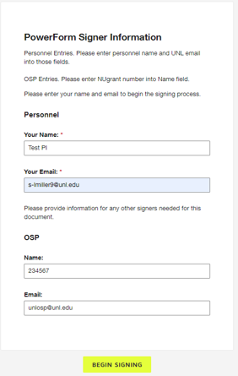

Step 3: Complete and Sign the Form
Fill in all required fields in the form. Select Sign to apply your electronic signature, then select Finish to submit the form. DocuSign routes the completed envelope to OSP and RCS automatically.

Step 4: Record Keeping for Users
After submission, DocuSign sends a completed copy to the user's email address and stores the envelope in the user's DocuSign account.

For OSP and RCS Specialists

Access Shared Envelopes
Log in to DocuSign and select the Manage tab. Choose Shared Envelopes and select your group to view submitted certification forms.
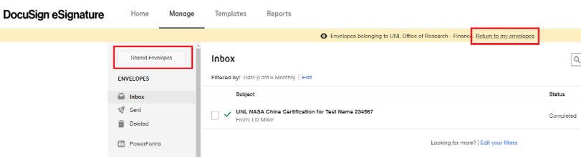

Review and Search Envelopes
Each envelope subject includes the personnel name and NUgrant form number. Select the subject to open the envelope and the attachment to view the completed form. Use the search field to filter results.

