UNL DOE Transparency of Foreign Connections Certiﬁcation

The UNL Department of Energy (DOE) Transparency of Foreign Connections Certiﬁcation shall be used for purposes of complying with federal regulations on DOE-sponsored projects. This certiﬁcation is speciﬁc to DOE and should not be used for projects not sponsored by DOE.
Please use the following link to begin the Certiﬁcation (if you have not already clicked on the link from the home page): https://go.unl.edu/doe_ftrp_certiﬁcation
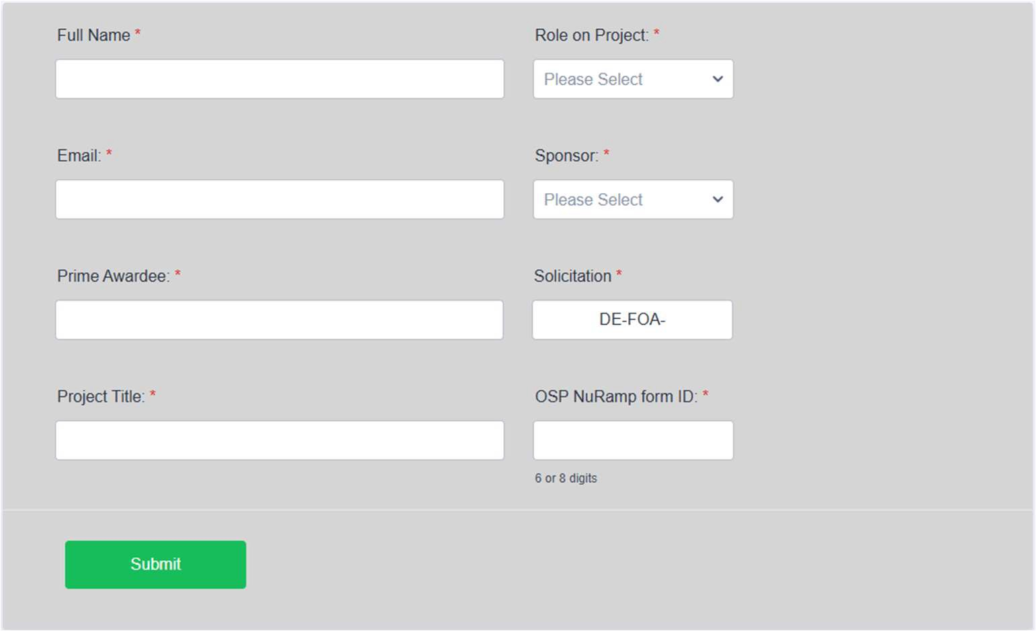

Full Name & Email: Please include ﬁrst and last name, and UNL email address.

*As a note, you will not be able to edit these ﬁelds once you click “submit”.

Prime Awardee: Please indicate the prime awardee of the DOE award. (e.g., if the prime awardee is UNL, please input “UNL”. If the prime awardee is another institution/entity, and UNL is the sub awardee, please input the other institution’s/entities name in this box.)

Project Title: Please include the full project title listed on the OSP Project.

Role on Project: Select your appropriate role on the project (e.g. PI, Co-PI, or Other Personnel). Your role on the project will determine what items you must certify on the form.

*As a note, you will not be able to edit your role once you click “submit”.

Sponsor: Select which DOE agency is sponsoring your project (e.g., DOE-ARPA-E, or other DOE agency).

*As a note, you will not be able to edit your role once you click “submit”.

Solicitation: There should be a solicitation (FOA/NOFO) associated with your project. Please enter the 7 digit solicitation number after “DE-FOA-“ (example: DE-FOA-0001234).

OSP NuRamp form ID: List the form ID associated with your OSP project.

The Form:
Within the form, you will be asked to certify that you are not currently participating in any Foreign Government-Sponsored Talent Recruitment Programs (FTRP) (including malign). Depending on your role on the project, and sponsor, you may also be asked to certify that no foreign equipment will be used on the project.

I certify that I am NOT participating in any Foreign Government-Sponsored Talent Recruitment Program (FTRP) (including malign) of any foreign country of concern. Further, I understand:
- Participation in FTRPs is prohibited per University of Nebraska
- Any changes to this information throughout the performance of this award must be submitted promptly.
- Failure to comply with this certification may result in termination of the award, payback of funds, or other consequences as detailed in EM 36 or required by the sponsor.

I certify that no foreign equipment is proposed for use on the project, including:
- Unmanned aircraft, control, and communications components originally made or manufactured in a foreign country of risk (including relabeled or rebranded equipment).
- Coded equipment where the source code is written in a foreign country of risk.
- Equipment from a foreign country of risk that will be connected to the internet or other remote communication system.
- Any entity from a foreign country of risk that will have physical or remote access to any part of the equipment used on the project after delivery.

All project personnel must complete a Foreign Government-Sponsored Talent Recruitment Program Certification. If you are a Principal Investigator or Co-Investigator, it is your responsibility to make sure everyone on the project has filled out the form.

After you have signed and submitted your certiﬁcation, your form will be routed NUtech Ventures. NUtech will further certify that there have been no technology licensing, transfer, or intellectual property sales to a foreign country of risk with respect to your project.

NUtech Official

I certify that there have been no technology licensing, transfer, or intellectual property sales to a foreign country of risk, in effect during the 5-year period preceding submission of the proposal within the same technology area as the application (e.g., batteries, biotechnology, grid, energy generation and storage, advanced computing) with respect to the individual indicated on this form.

______________________________
Signature

______________________________
Printed Name

____________________
Date

