Job Aid: SF 424 Form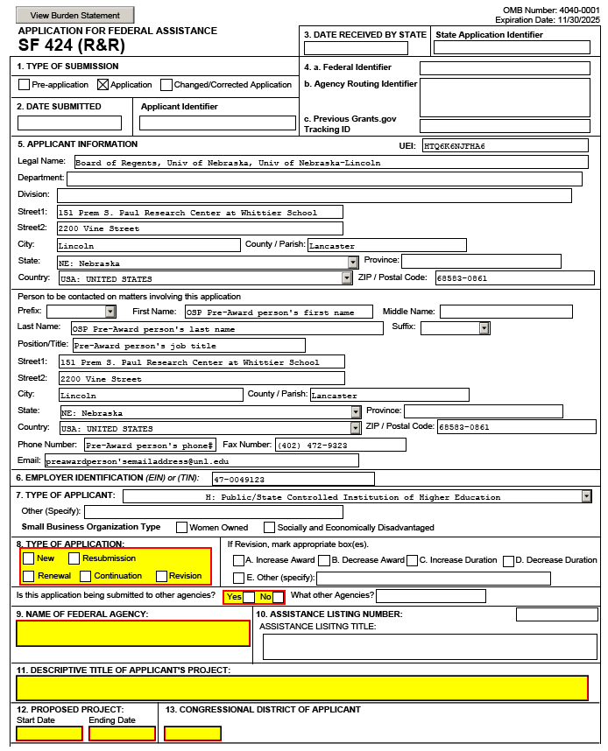
Check the solicitation to see if there are special requirements for these fields.
Use the following: [PI last name] [sponsor abbreviation] [NuRamp form ID]
e.g. Smith DOE 123456
Contact should be the OSP Pre-Award individual submitting the proposal.

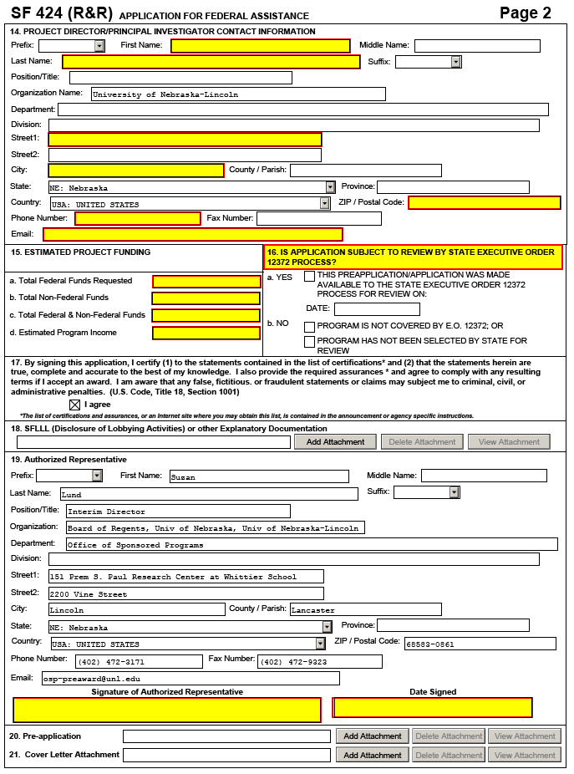
Check the solicitation to see if this applies.

