UNL Animal Care Program

Animal Research Training & Orientation Instructions
  - (for those working in the Life Science Annex & Manter Hall)

Introduction
Hello and welcome to the University of Nebraska – Lincoln Animal Care Program (ACP). We are excited for you to join the animal research/teaching field and would like to provide you with the information to make your training and orientation requirements as easy as possible.
Below are the items that must be completed PRIOR to having any animal contact and/or working in the facility:
- IACUC General Regulation Training (GRT)
- Occupational Health and Safety (OHS) Program enrollment
- Anesthesia training (if applicable – check with your faculty supervisor)
- Listed on PI’s IACUC Protocol(s)
- Orientation for your respective facility
- Facility Access Form signed by PI and submitted to the Animal Care Program (ACP)

IACUC General Regulation Training (GRT)
All individuals handling UNL research and teaching animals are required to complete Institutional Animal Care and Use Committee (IACUC) General Regulation Training (GRT) before they can be approved to work on an IACUC protocol. The GRT is valid for five years and must be renewed after this time. There are two ways to complete the GRT training requirement.
- At the beginning of the fall and spring semesters in-person GRT training is offered on both campuses. This hour-long session can be attended by anyone interested, and registration is not required to attend. Occasionally, other in-person sessions may be offered throughout the year. Questions about upcoming GRT sessions can be directed to Megan Ebbers, ACP Assistant Director (mebbers2@unl.edu).
- The GRT can also be completed online through www.citiprogram.org.
  - Online GRT Instructions
- Go to the CITI Program website (www.cititiprogram.org).
- Click register at the top of the page to get started, if you do not already have a profile created.
- Step 1: Click on the option to “Select Organization Affiliation.” Enter “University of Nebraska – Lincoln” into the box and select it from the choices.
- Step 2: Enter your personal information (name and email address).
- Step 3: Create your username and password.
- Step 4: Complete your learner registration.
- Step 5: Select “No” for CEU’s, unless you wish to pay on your own.
- Step 6: Continue to enter your personal information (institutional email address, highest degree, department, role, and phone number).
- Step 7: Under “Question 1” select the appropriate course, “Animal Care and Use General Regulations Training (GRT) – required by the IACUC.”

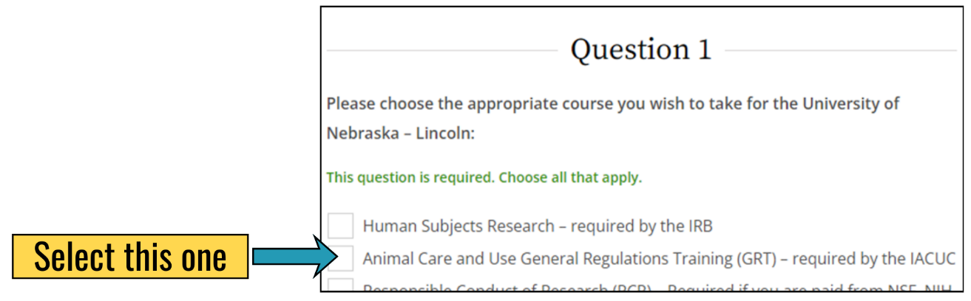
- Step 8: Under “Question 6” select you are not an IACUC member.
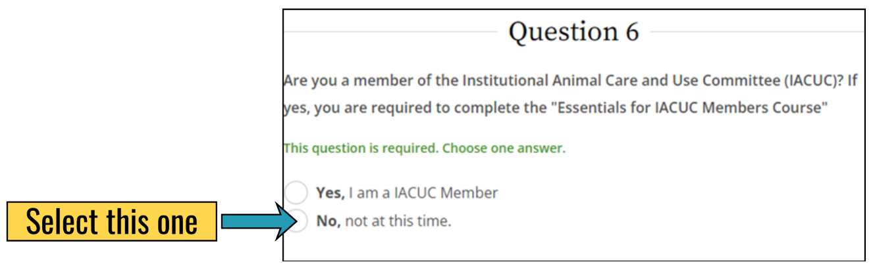
- Step 9: Under “Question 7” indicate whether you will be conducting surgery. Ask your supervisor if you are unsure what your lab work will include.
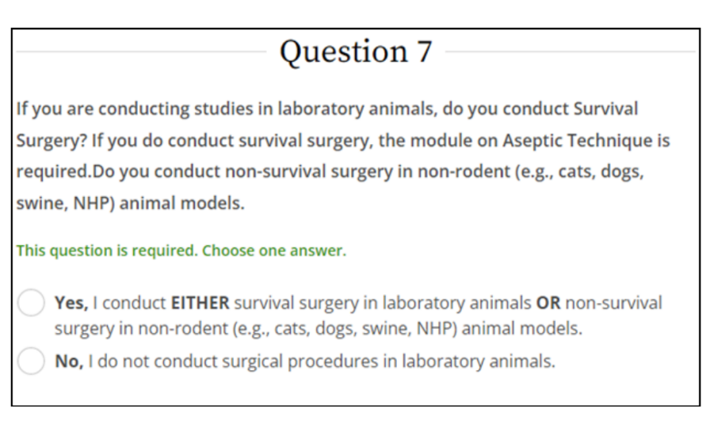
- Step 10: Under “Question 8” select the appropriate course(s). The course that fulfills the IACUC GRT training requirement is the first one listed (“Working with the IACUC Course”). Note: All other courses are optional but do contain good information.
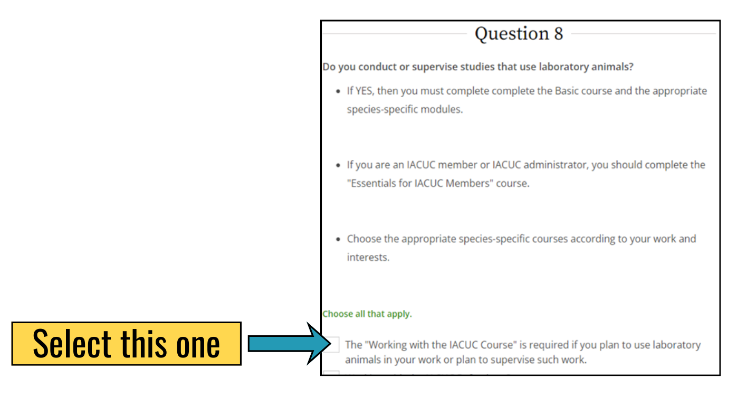
- Step 11: The course will show up as, “Investigators, Staff and Students” on your profile.
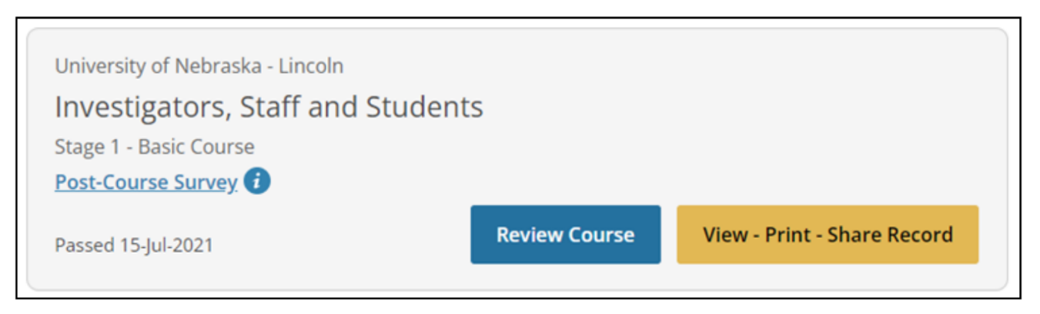
Note: Individuals MUST pass a majority of the nine modules to get credit for completing the IACUC GRT training.

Occupational Health & Safety (OHS) Program Enrollment
All personnel handling research and teaching animals at UNL should be enrolled in the Occupational Health & Safety Program. The enrollment can be found online at: https://go.unl.edu/iacp_ohs_form. The form is to be completed and submitted online via Docusign. Once submitted the Animal Care Program (ACP) OHS Nurse will review your form and if needed follow up with you.
Note: The form needs to be filled out completely, please ask your supervisor if you have questions about a section.
If you have any questions about the OHS form or enrollment process, please reach out to the ACP OHS Nurse, Stephanie Padilla (spadilla5@unl.edu).

Anesthesia Training
All personnel in labs using gas anesthesia at UNL are required to complete online Anesthesia Training. The training can be found online at: https://go.unl.edu/iacp_anesthesia.
Please check with your supervisor to determine if this is an expectation in the lab in which you will be working. If you have any questions about the anesthesia training, please reach out to Dr. Melissa Bausch, ACP Senior Clinical Veterinarian (mbausch2@unl.edu).

Facility Orientation
Once you have completed the necessary training and forms the Facility Supervisor will be contacted to set up an orientation time for you. To schedule an orientation, you must have your GRT training completed, OHS form submitted and reviewed by the ACP OHS Nurse, and anesthesia training finished (if applicable) before an orientation can be scheduled.

Facility Access Form
To be granted key card access to the facility you will also need to submit a completed Facility Access Form, signed by the Principal Investigator (PI) you will be working with. The form can be found online at: https://research.unl.edu/researchresponsibility/forms/.

NOTE
The UNL Animal Care Program’s centrally managed facilities (Life Science Annex and Manter Hall) are secure facilities that require key card access. Key card access must be granted by the Animal Care Program to enter the facility. “Piggybacking” into the facility with someone else or using someone else’s key card to access the facility is strictly prohibited. Please help do your part to keep our research building safe and secure.

Questions
Please contact the Animal Care Program Office with any questions.
- Jessica Jones Animal Care Program Specialist jjones12@unl.edu 402-472-0765
- Megan Ebbers Animal Care Program Assistant Director mebbers2@unl.edu 402-472-4486

