Interest and Outside Activity Reporting Form Help Document
Individuals disclose financial interests and outside professional activities related to their institutional responsibilities through this secure NUgrant module.
Following are step by step instructions on how to create your Interest and Outside Activity Reporting Form. If you have additional questions, please contact the Office of Research Responsibility at (402)472-6965.
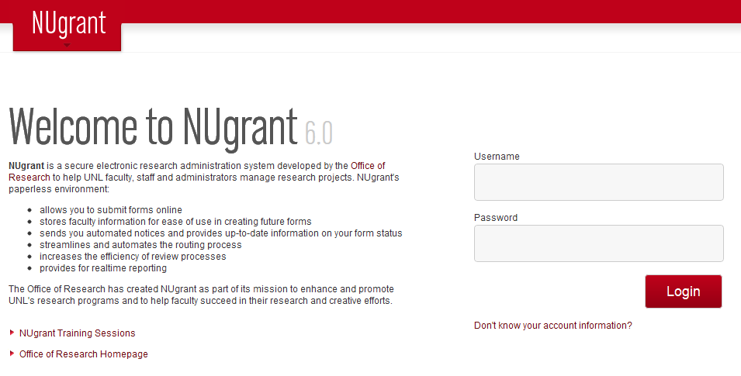

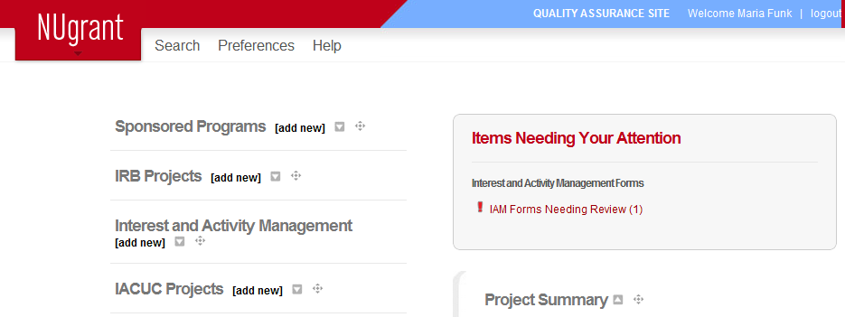

Log into NUgrant at nugrant.unl.edu using your Blackboard login name and password.
If you do not know your login information, go to my.unl.edu. There will be a link to obtain this information.

Under the Interest and Activity Management section, select add new.

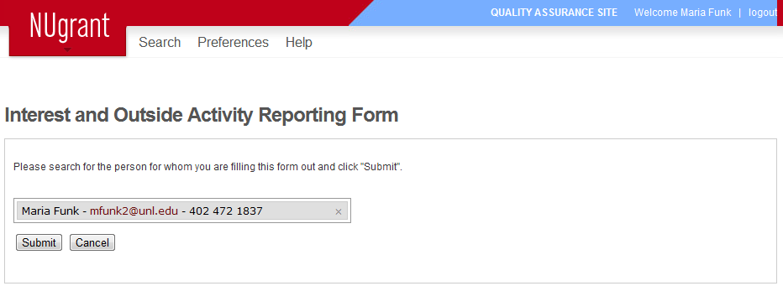

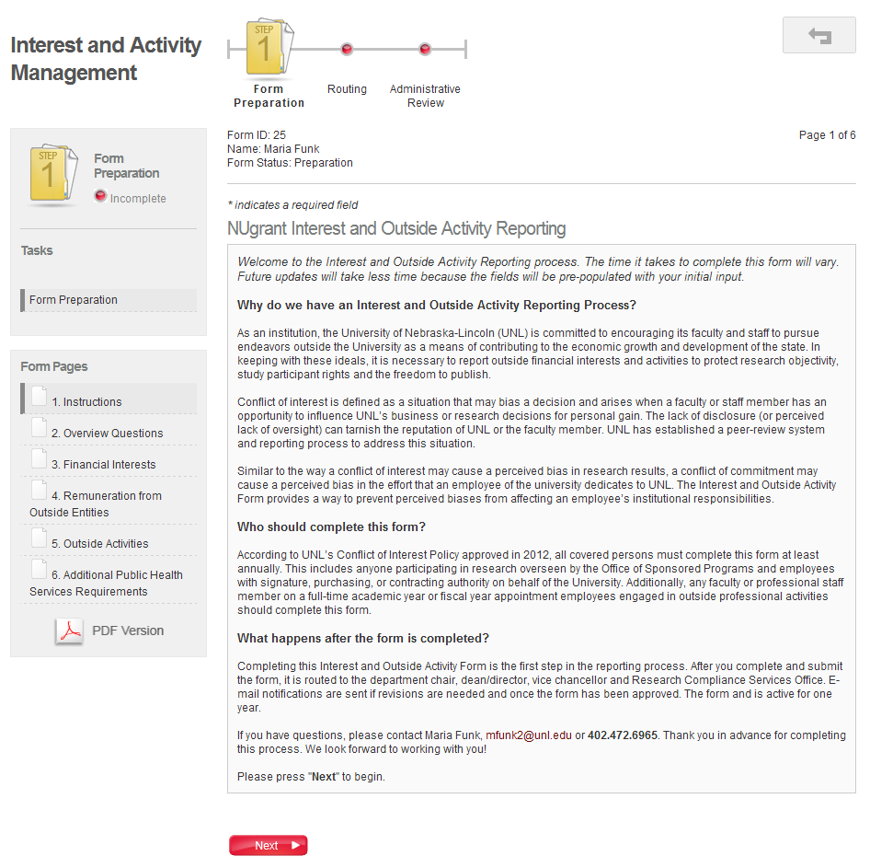

Your name will automatically appear on the next page.
If you are starting the form for someone else, click the x next to your own name, and type the person’s name into the text box.
Click on Submit.

Read the instructions.

Click on Next.

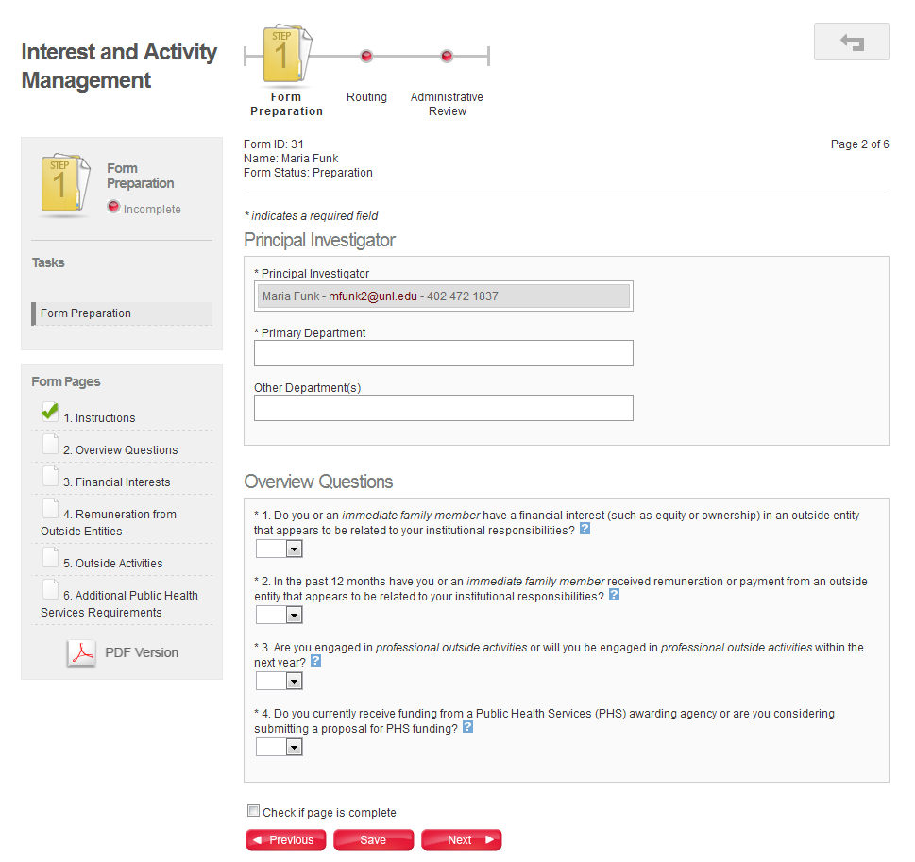

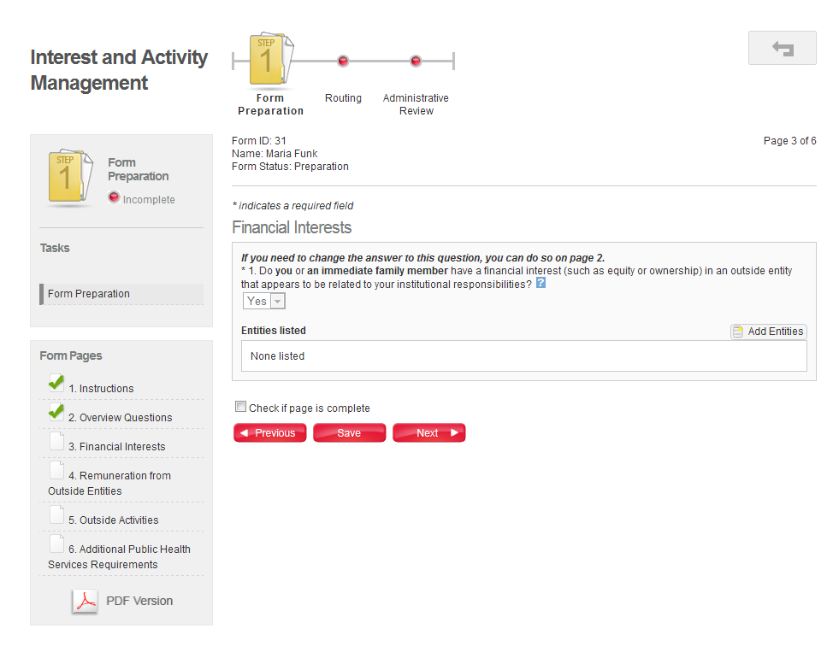

Select your Department(s) by typing a search term.

The four Overview Questions correspond to the remaining Form Pages.

Click on blue question mark boxes to see more information to help you answer these questions.

Check this box on each page to indicate that it is complete.

If you answered “Yes” and have financial interests to report, add an entity here.
You may add multiple entities.

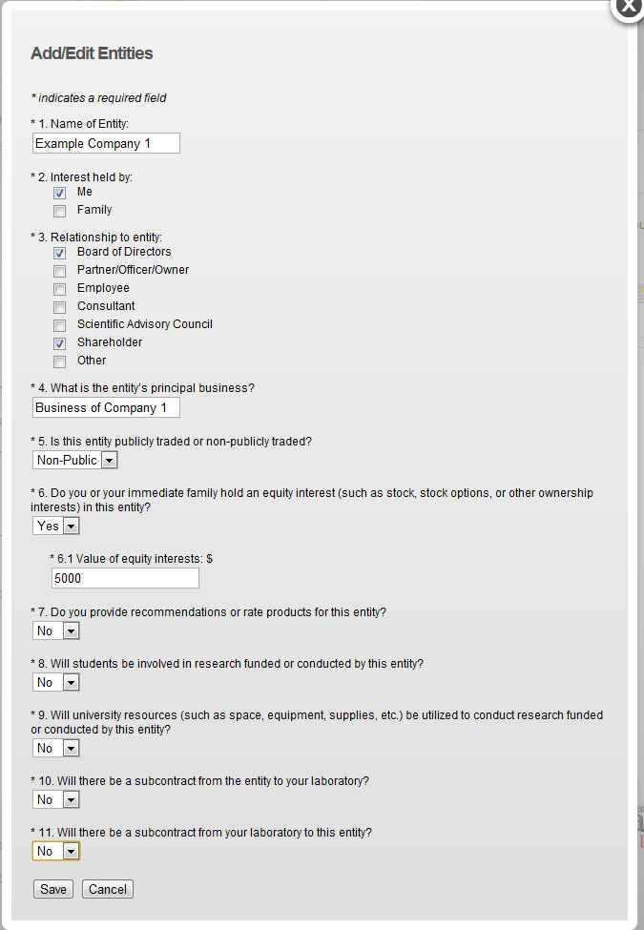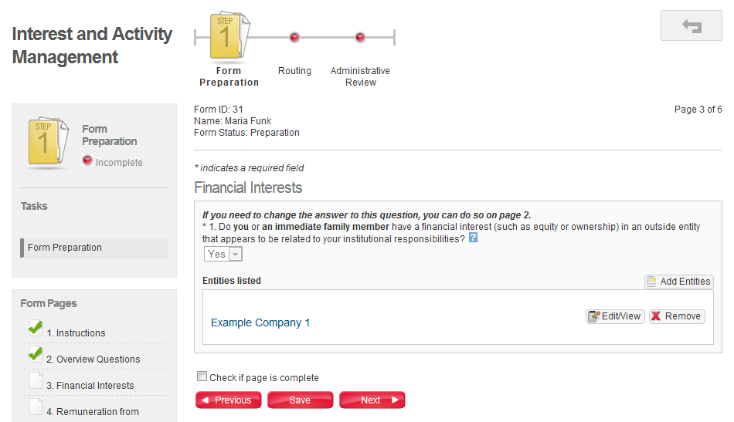

Answer the questions about your financial interest in the popup window.

Click on Save.

Now your financial interests in this entity are listed here.

Click Add Entities if you have more financial interests to report here.
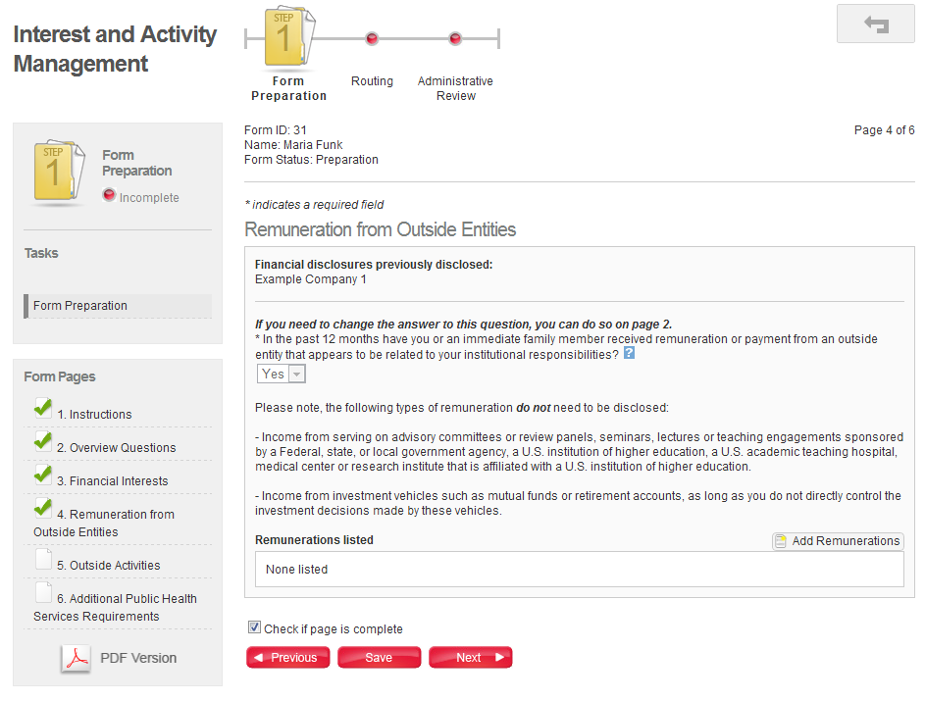

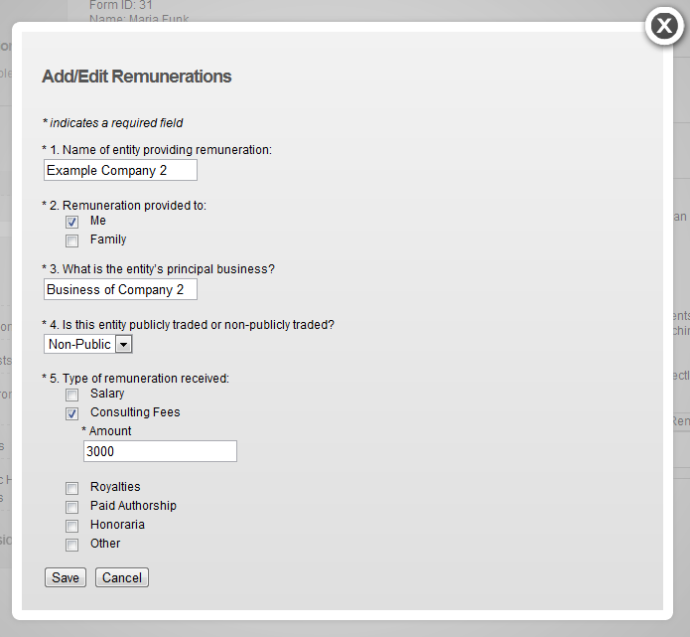

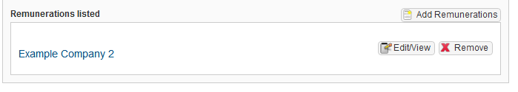

If you answered “Yes” to this question and have remunerations from outside entities to report, add remuneration here.
You may add multiple remunerations.

Answer the questions about your remuneration in the popup window.

Click on Save.

Now your remunerations are listed here.

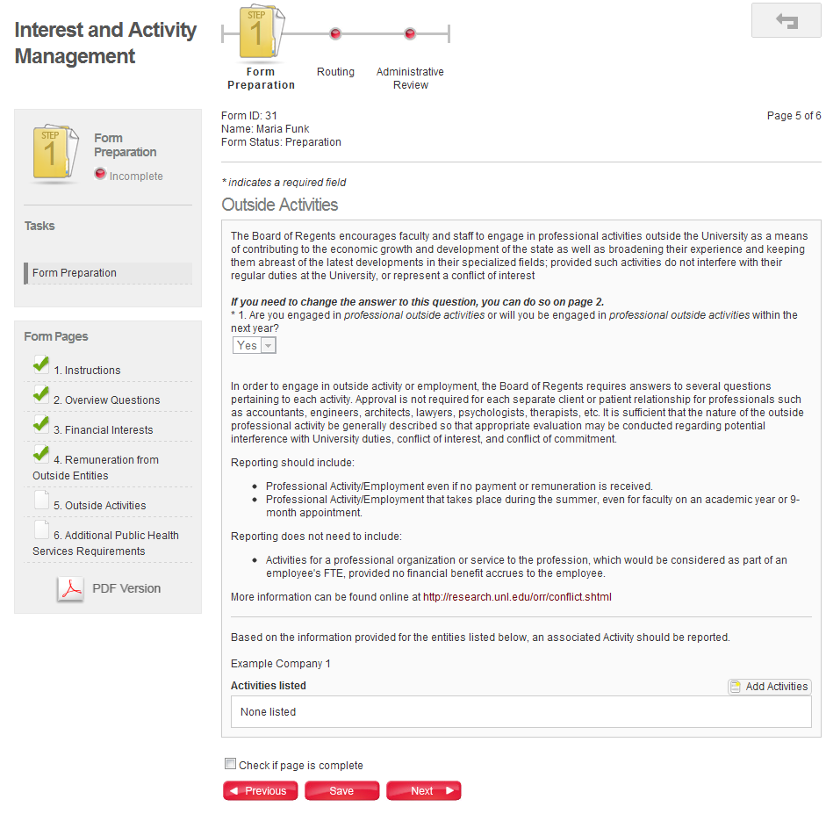
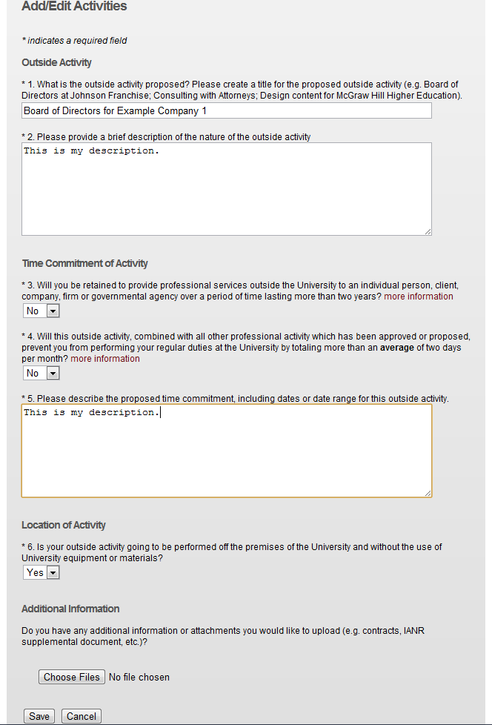

Note that recommendations of activities you should report appear here (if applicable) based on your previous answers in the form.

If you answered “Yes” to this question and have outside activities to report, add an activity here.
You may add multiple activities.

Answer the questions about your outside activity.

Click on Save.

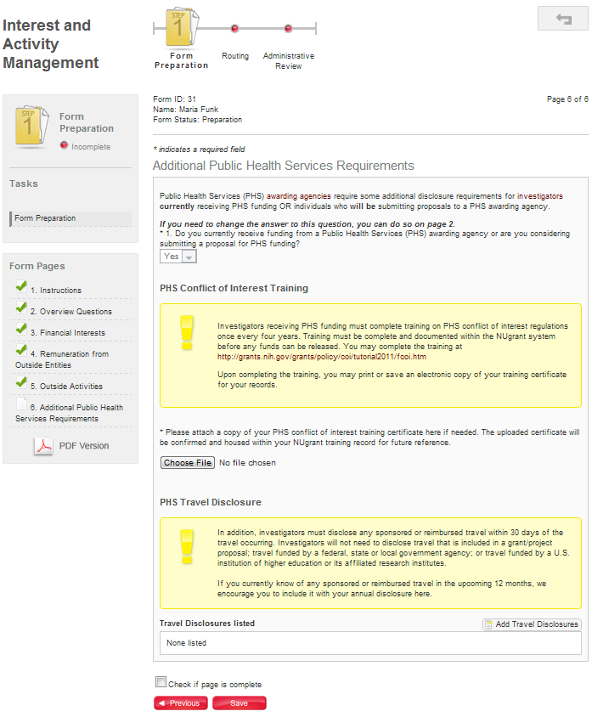

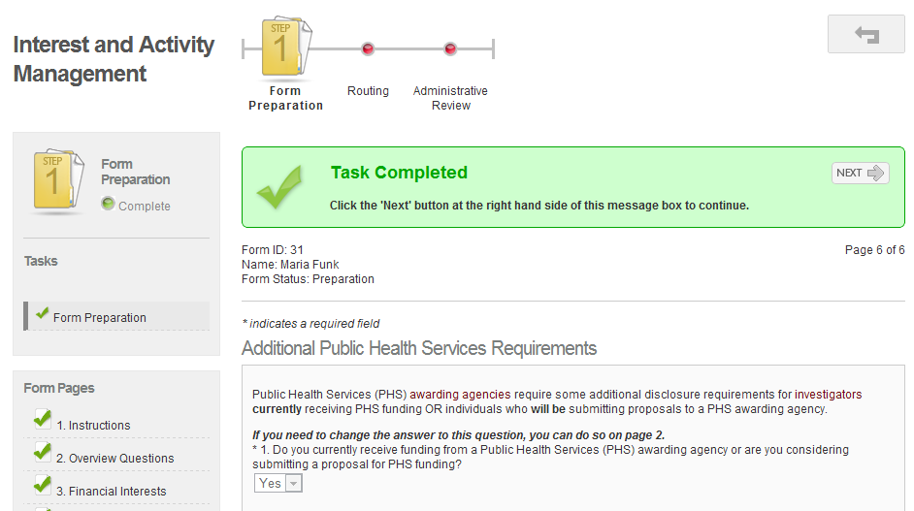

If you answered “Yes” to this question and seek or receive Public Health Service funding, you must complete and understand the additional requirements on this page.

Once you have completed all of the pages and checked the box at the end of each page, you will see a green bar at the top of the page that says “Task Completed”. Click on the Next button.

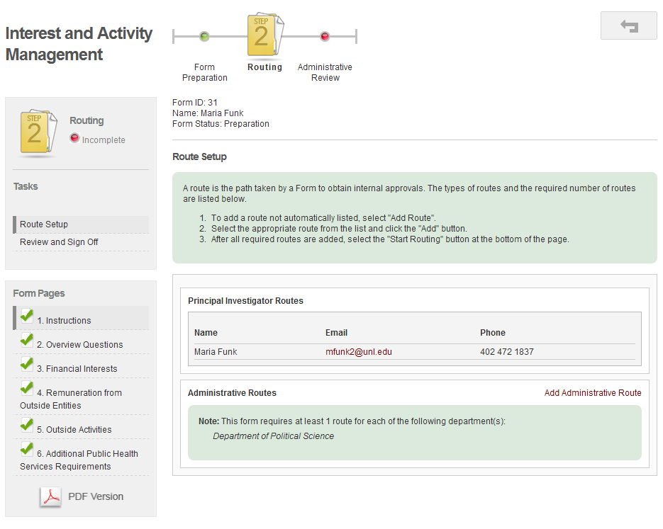

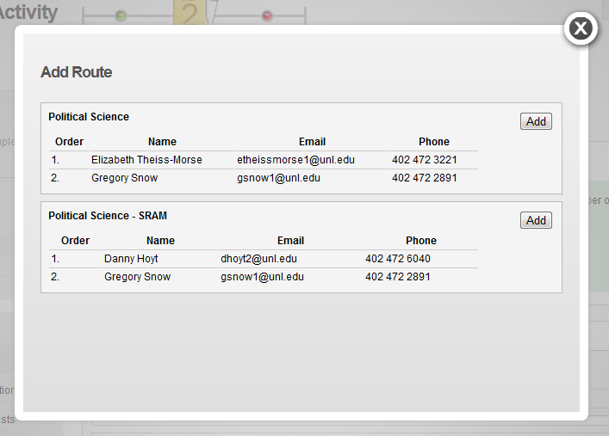

Click on Add Administrative Route.

Possible routes will appear based on your department. Click on Add next to the route you want to select.
You may add multiple routes.
If the correct route is not listed, please contact the Office of Research Responsibility at (402) 472-6965.

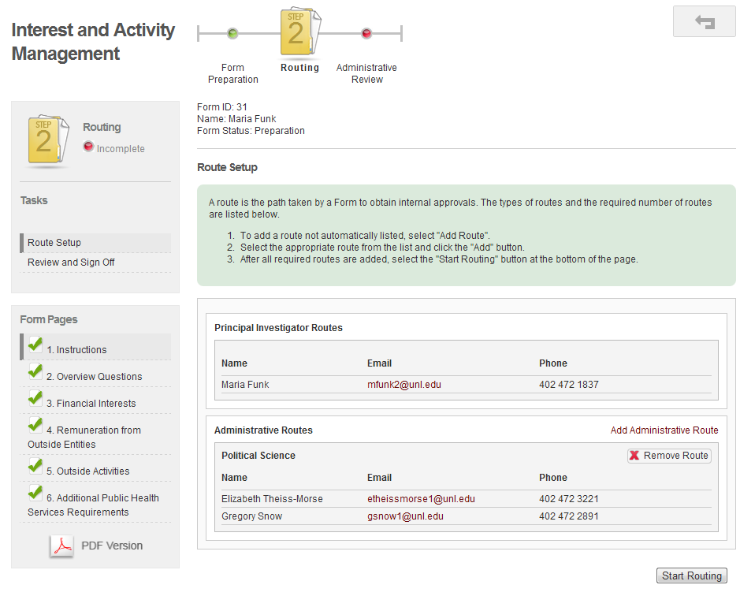

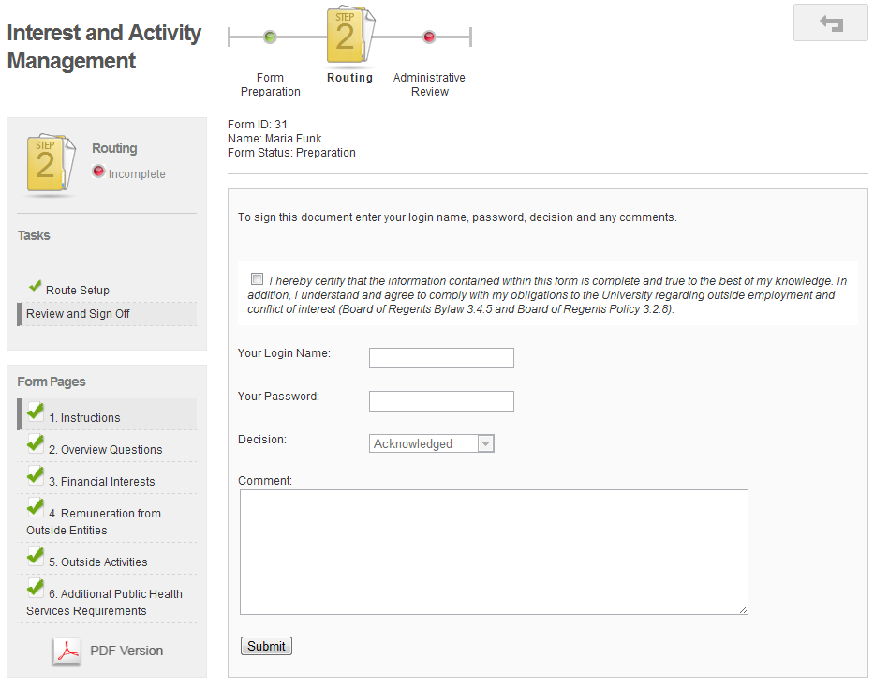

Once you have added the correct route(s), click on Start Routing. This sends an email to those people listed on the route indicating that they need to sign the form.

Once you have read and understood the attestation, please certify your form by checking this box.

Sign the form using your NUgrant login and password.

Click on Submit.

